**Second-Order Systems**

**Topics Covered**

• Underdamped second-order systems.

• Damping ratio and natural frequency.

• Peak time and percent overshoot time-domain specifications.

**Prerequisites**

• Integration laboratory experiment.

• Filtering laboratory experiment.

**1 Background**

**1.1 Second-Order Step Response**

The *standard second-order* transfer function has the form

*Y* (*s*) *ω*2

*R*(*s*)

=  *n ,* (1.1)

*s*2 + 2*ζ ωn s* + *ω*2

*n*

where *ωn* is the natural frequency and *ζ* is the damping ratio. The properties of its response depend on the values of the parameters *ωn* and *ζ* .

Consider a second-order system as shown in Equation 1.1 subjected to a step input given by

*R*0

*R*(*s*) = *, s*

with a step amplitude of *R*0 = 1*.*5. The system response to this input is shown in Figure 1.1, where the red trace is the output response *y*(*t*) and the blue trace is the step input *r*(*t*).

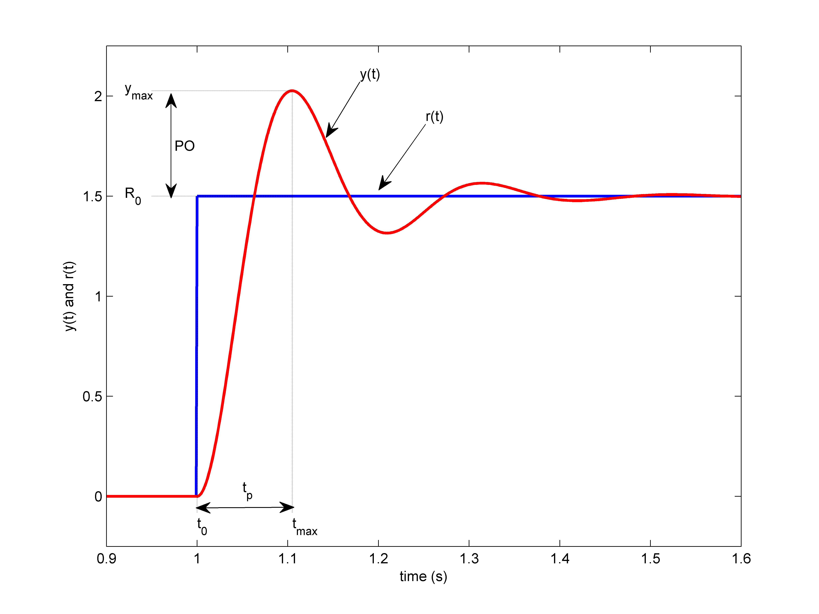

Figure 1.1: Standard second-order step response

**1.2 Peak Time and Overshoot**

The maximum value of the response is denoted by the variable *ymax* and it occurs at a time *tmax* . For a response similar to Figure 1.1, the percent overshoot is found using

100 (*ymax − R*0 )

*P O* =

*.* (1.2)

*R*0

From the initial step time *t*0 the time it takes for the response to reach its maximum value is

*tp* = *tmax − t*0 *.* (1.3)

This is called the *peak time* of the system.

In a second-order system, the amount of overshoot depends solely on the damping ratio parameter and it can be calculated using the equation

*P O* = 100*e*

(  *πζ* )

*− √*1*−ζ*2

*.* (1.4)

The peak time depends on both the damping ratio and natural frequency of the system and it can be derived as:

*π*

*−*

*n*

*tp* =

*ω* √ 1 *ζ* 2 *.* (1.5)

Generally speaking, the damping ratio affects the shape of the response while the natural frequency affects the speed of the response.

**1.3 Unity Feedback**

The unity-feedback control loop shown in Figure 1.2 will be used to control the position of the QUBE-Servo 2.

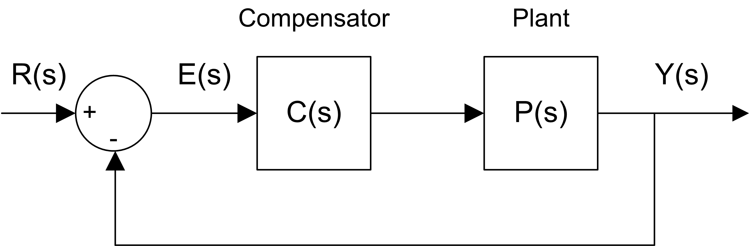

Figure 1.2: Unity feedback loop

The QUBE-Servo 2 voltage-to-position transfer function is

*P* (*s*) =

Θ*m* (*s*)

*Vm* (*s*)

*K*

=

*s*(*τ s* + 1)

*.* (1.6)

where *K* = 21*.*9 rad/(V *−* s) is the model steady-state gain, *τ* = 0*.*15 s is the model time constant, Θ*m* (*s*) = *L* [*θm* (*t*)] is the motor / disk position, and *Vm* (*s*) = *L* [*vm* (*t*)] is the applied motor voltage. If desired, you can conduct an experiment to find more precise model parameters *K* and *τ* for your particular servo (e.g. performing the Bump Test Modeling laboratory experiment).

The controller is denoted by *C* (*s*). In this lab, we are only going to use unity feedback therefore

*C* (*s*) = 1*.* (1.7)

The closed-loop transfer function of the QUBE-Servo 2 position control from the reference input *R*(*s*) = Θ*d* (*s*) to the output *Y* (*s*) = Θ*m* using unity feedback as shown in Figure 1.2 is

Θ*d* (*s*) *K*

=  *τ .* (1.8)

*Vm* (*s*)

*s*2 + 1 *s* +  *K*

*τ τ*

**2 In-Lab Exercises**

Based on the VI developed in the Integration laboratory experiment, design the VI shown in Figure 2.1. This implements the unity feedback control given in Figure 1.2. A step reference of 1 rad is applied at 1 second and the controller runs for 2.5 seconds. This is the desired position or setpoint signal.

To apply your step for a 2.5 seconds, set the *Final Time* of the Simulation Loop to 2.5 (instead of *inf* ). Using the saved response, the peak time and overshoot can be found as discussed in Section 1. As shown in Figure 2.1, the unity feedback step response is ”saved” using the Collector block from the *Control & Simulation* | *Simulation* | *Utilities* palette and displayed in an XY Graph. LඉඊVIEW™ graphs (as opposed to charts) have cursors that can be used to take measurements.

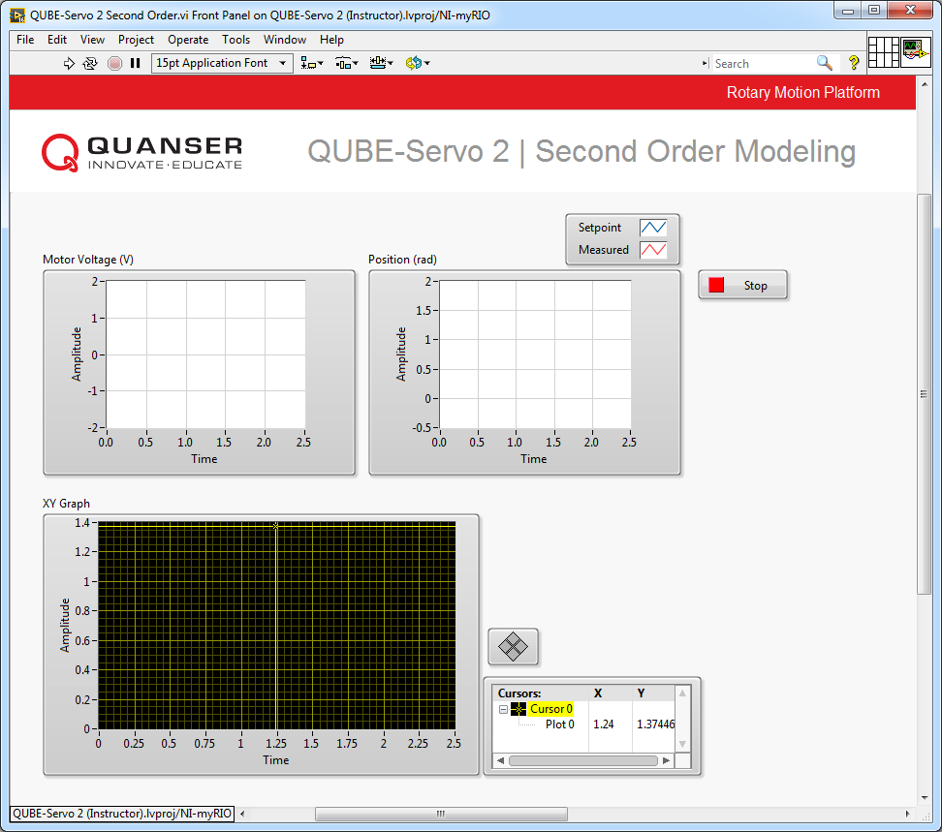

(a) Front Panel

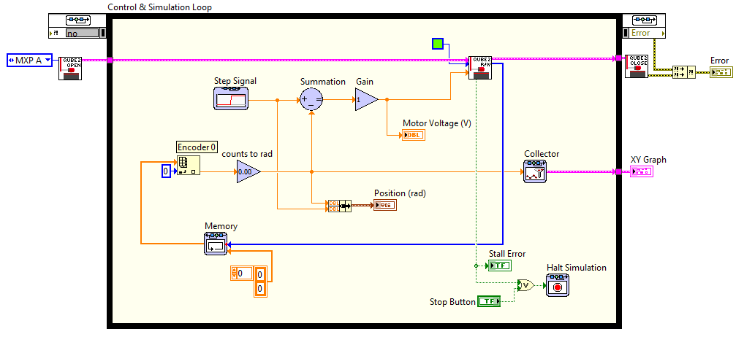

(b) Block Diagram

Figure 2.1: Unity feedback position control of QUBE-Servo 2

1. Given the QUBE-Servo 2 closed-loop equation under unity feedback in Equation 1.8 and the model parameters above, find the natural frequency and damping ratio of the system.

2. Based on your obtained *ωn* and *ζ* , what is the expected peak time and percent overshoot?

3. Run the VI. The scopes should look similar to Figure 2.2.

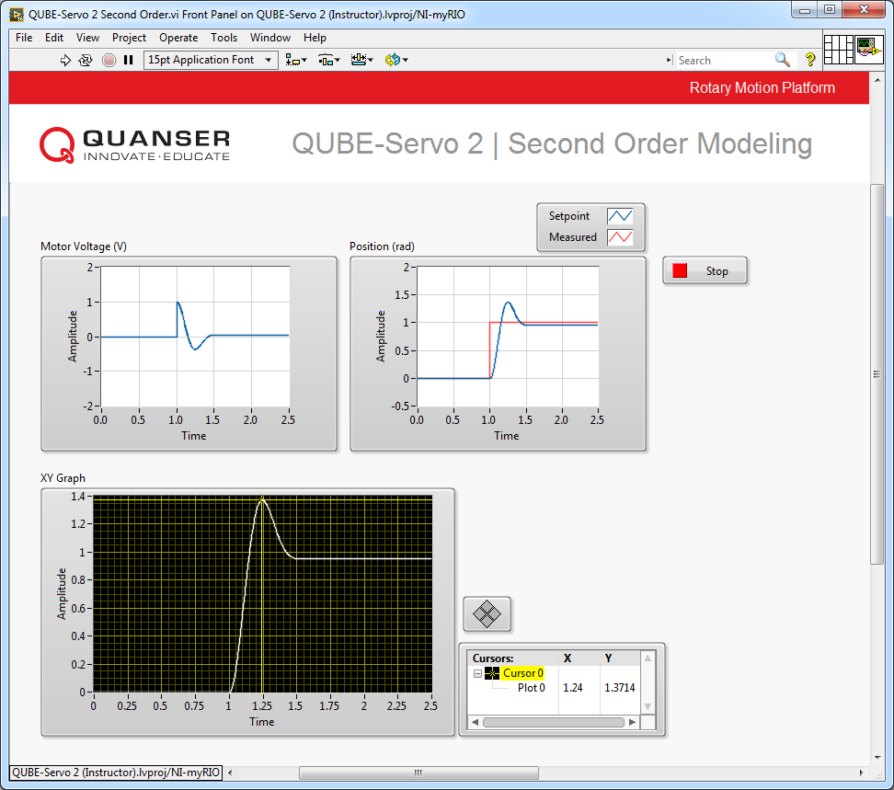

Figure 2.2: Unity feedback QUBE-Servo 2 step response

4. Attach the QUBE-Servo 2 position response, showing both the setpoint and measured positions in one scope as well as the motor voltage. To do this, you can use the *Export* | *Export Simplified Image* to save the measured load/disk speed and motor voltage to a picture file and attach that to your report.

5. Measure the peak time and percent overshoot from the response and compare that with your expect results.

**Hint:** Use the cursor palette in the XY Graph to measure points off the plot.

6. Click on the Stop button to stop the VI.

7. Power *OFF* the QUBE-Servo 2.

© 2017 Quanser Inc., All rights reserved.

Quanser Inc.

119 Spy Court

Markham, Ontario

L3R 5H6

Canada

[info@quanser.com](mailto:info@quanser.com)

Phone: 1-905-940-3575

Fax: 1-905-940-3576

Printed in Markham, Ontario.

For more information on the solutions Quanser Inc. offers, please visit the web site at:

[http://www.quanser.com](http://www.quanser.com/)

This document and the software described in it are provided subject to a license agreement. Neither the software nor this document may be used or copied except as specified under the terms of that license agreement. Quanser Inc. grants the following rights: a) The right to reproduce the work, to incorporate the work into one or more collections, and to reproduce the work as incorporated in the collections, b) to create and reproduce adaptations provided reasonable steps are taken to clearly identify the changes that were made to the original work, c) to distribute and publically perform the work including as incorporated in collections, and d) to distribute and publicly perform adaptations. The above rights may be exercised in all media and formats whether now known or hereafter devised. These rights are granted subject to and limited by the following restrictions: a) You may not exercise any of the rights granted to You in above in any manner that is primarily intended for or directed toward commercial advantage or private monetary compensation, and b) You must keep intact all copyright notices for the Work and provide the name Quanser Inc. for attribution. These restrictions may not be waved without express prior written permission of Quanser Inc.